
HS902 Manual Task Risk Management Form

Faculty/Division: |  |  | School/Unit:
Document number | Initial Issue date | Current version |  | Current Version  Issue date | Next review date

Hazardous Manual Tasks – Definition: “Any task that requires a person to lift, lower, push, pull, carry or otherwise move, hold or restrain any person, animal or thing, involving one or more of the following: repetitive or sustained force; high or sudden force; repetitive movement; sustained or awkward posture, or exposure to vibration.

Name of Task:
Assessed by (Name and position i.e. Manager; Supervisor; worker; HSR): | Date of assessment: | Location of task:
Reason for assessment:

☐ Existing task ☐ New Task ☐ New Information ☐ Change in task, object or tool ☐ Report of a Musculoskeletal disorder (MSD)
Description of the hazardous manual task:

Description of the workplace environment, layout and physical conditions:

Identify hazards and determine control measures to eliminate or reduce the risk of injury – Break down the task/activity into steps and at each step, identify any of the below with a tick ✓ in the Yes column

Step 1: Does the task involve repetitive (the movement of force is performed twice a minute) and/or sustained (the posture or force is held for more than 30 seconds at a time) movements, postures or forces? (refer to Appendix 1 for examples) | Yes
Back
1.1 Bending or twisting more than 20 degrees – forwards
1.2 Bending or twisting more than 20 degrees – sideways
1.3 Bending more than 5 degrees - backwards
Neck or Head
1.4 Bending or twisting more than 20 degrees – forwards
1.5 Bending or twisting more than 20 degrees – sideways
1.6 Bending more than 5 degrees - backwards
Arms/Hands
1.7 Working with one or both hands above shoulder height
1.8 Reaching forwards or sideways more than 30cm from the body
1.9 Reaching behind the body
1.10 Excessive bending of the wrists
1.11 Twisting, turning, grabbing, picking or wringing actions with the fingers, hands or arms
Legs
1.12 Squatting, kneeling, crawling, lying, semi-lying or jumping
1.13 Standing with most of the body’s weight on one leg
Very fast movements
1.14 Lifting or lowering
1.15 Carrying with one hand or one side of the body
1.16 Exerting force with one hand or one side of the body
1.17 Pushing, pulling or dragging
1.18 Very fast actions
1.19 Working with fingers close together or wide apart
1.20 Applying uneven, fast or jerky forces
1.21 Holding, supporting or restraining anything (including a person, animal or tool)

If you ticked Yes to any of the above, you should consider the Duration of the task. The longer the task is performed, the more hazardous it can be. | Yes
1.22 More than 2 hours a whole shift
1.23 Continually for more than 30 minutes at a time

Step 2: Does the task involve sudden or high force, even if the force is only applied once? | Yes
2.1 Lifting, lowering or carrying heavy loads
2.2 Throwing or catching
2.3 Hitting, kicking or jumping
2.4 Applying a sudden or unexpected force including:
- Handling a live person or animal, or
- Applying uneven fast or jerky forces during lifting, carrying, pushing or pulling, or
- Pushing or pulling objects that are hard to move or stop e.g. a trolley

2.5 Exerting force while in a bent, twisted or awkward posture including:
- Supporting items with hands above shoulder height, or
- Moving items when legs are in an awkward posture, working with fingers pinched together or held wide apart, or
- Using a finger grip or pinch grip or an open-handed grip
2.6 Exerting a force with the non-preferred hand
2.7 Needing to use two hands to operate a tool designed for one hand
2.8 The task can only be done for short periods of time
2.9 Two or more people need to be assigned to handle a heavy, awkward or bulky load
2.10 Workers report pain or significant discomfort during or after the task
2.11 Stronger workers are assigned to do the task
2.12 Workers say the task is physically very strenuous or difficult to do
2.13 Workers think the task should be done by more than one person, or seek help to the do the task if it required high force

Step 3: Is there hand, arm or whole-body vibration? | Yes
3.1 Driving for long periods
3.2 Driving on rough roads
3.3 Frequent or prolonged use of hand powered tools
3.4 Using high grip forces or awkward postures when using power tools
3.5 Use of machines or tools where the manufacturers handbook warns of vibration
3.6 Workers being jolted or continually shaken
3.7 Use of a vehicle or tool not suitable for the environment or task

Step 4: Are environmental factors increasing the risk? | Yes
4.1 High temperatures or radiant heat
4.2 Low temperatures
4.3 High winds
4.4 High humidity
4.5 Handling hot or cold objects
4.6 Floor/ground is slippery, wet, or not level
4.7 Working in a restricted space e.g. an overcrowded or small storeroom
4.8 Wearing protective or thick clothing, affecting comfort or handling

Step 5: Are organisational factors increasing the risk? | Yes
5.1 Peak, busy periods/sudden variations in workload
5.2 Need for speed and/or accuracy
5.3 Long work hours or work force shortages
5.4 Other factors? For example – lack of supervision and support; training in specific hazardous manual tasks; employment relationships i.e. casual staff; gender expectations
Please describe:

Step 6: Where any of the above tasks have been identified as a risk (i.e. where Yes has been ticked) – controls need to be documented?
Transfer risk detail to the be below table
Item No. (i.e. 1.1) | This action happens when and why (describe) | Existing controls in place to reduce the risk | Are there any other additional controls required to reduce the risk | Risk Rating

Risk Rating Matrix
RISK RATING METHODOLOGY AND MATRIX
Consider the Consequences  Consider: What type of harm could occur (minor, serious, death)? Is there anything that will influence the severity (e.g. proximity to hazard, person involved in task etc.). How many people are exposed to the hazard? Could one failure lead to other failures? Could a small event escalate? | Consider the Likelihood  Consider: How often is the task done? Has an accident happened before (here or at another workplace)? How long are people exposed? How effective are the control measures? Does the environment effect it (e.g. lighting/temperature/pace)? What are people’s behaviours (e.g. stress, panic, deadlines) What people are exposed (e.g. disabled, young workers etc.)? | Calculate the Risk  1.Take the consequences rating and select the correct column  2.Take the likelihood rating and select the correct row  3. Select the risk rating where the two ratings cross on the matrix below.  VH = Very high, H = High, M = Medium, L = Low
   |  | CONSEQUENCES
   |  | 1 | 2 | 3 | 4 | 5
  LIKELIHOOD | A | M | H | H | VH | VH
  LIKELIHOOD | B | M | M | H | H | VH
  LIKELIHOOD | C | L | M | H | H | VH
  LIKELIHOOD | D | L | L | M | M | H
  LIKELIHOOD | E | L | L | M | M | M
5. Severe: death or permanent disability to one or more persons  4. Major: hospital admission required  3. Moderate: medical treatment required  2. Minor: first aid required  1. Insignificant: injuries not requiring first aid | A. Almost certain: expected to occur in most circumstances  B. Likely: will probably occur in most circumstances  C. Possible: might occur occasionally  D. Unlikely: could happen at some time  E. Rare: may happen only in exceptional circumstances

Risk level | Required action
Very high | Act immediately: The proposed task or process activity must not proceed. Steps must be taken to lower the risk level to as low as reasonably practicable using the hierarchy of risk controls
High | Act today: The proposed activity can only proceed, provided that: (i) the risk level has been reduced to as low as reasonably practicable using the hierarchy of risk controls and  (ii) the risk controls must include those identified in legislation, Australian Standards, Codes of Practice etc. and  (iii) the document has been reviewed and approved by the Supervisor and  (iv) a Safe Working Procedure or Safe Work Method has been prepared and  (v) the supervisor must review and document the effectiveness of the implemented risk controls
Medium | Act this week: The proposed task or process can proceed, provided that: (i) the risk level has been reduced to as low as reasonably practicable using the hierarchy of controls and  (ii) the document has been reviewed and approved by the Supervisor and  (iii) a Safe Working Procedure or Safe Work Method has been prepared.
Low | Act this month: Managed by local documented routine procedures which must include application of the hierarchy of controls.

Step 7: Assign responsibility for implementing additional controls

Additional control measures needed: | Resources required | Responsible person | Date of implementation
 |  |  | Click here to enter a date.
 |  |  | Click here to enter a date.
 |  |  | Click here to enter a date.
 |  |  | Click here to enter a date.
 |  |  | Click here to enter a date.
 |  |  | Click here to enter a date.

Review: Complete this section if reviewing original assessment or after an injury

Scheduled review date: | Click here to enter a date.
Are all control measures in place?
Are controls eliminating or minimising the risk?
Are there any new problems with the risk?
Review by: (name)
Review date: | Click here to enter a date.

Acknowledgement of Understanding
All persons performing these tasks must sign that they have read and understood the risk management (as described in HS329 Risk Management Procedure).

Risk management name and version number: I have read and understand this risk management form
Name | Signature | Date

Appendix 1: Examples of postures, movements and forces that pose a risk if they are repetitive or sustained

Bending the back or head forwards or sideways more than 20 degrees  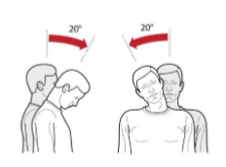 |  | Bending the back or head backwards more than 5 degrees or looking up  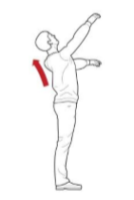 |  |  | Twisting the back or neck more than 20 degrees  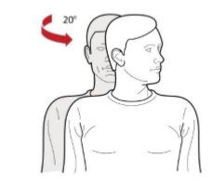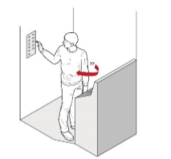 |  |  | Twisting, turning, grabbing, picking or wringing actions with the fingers, hands or arms that includes excessive bending of the wrist  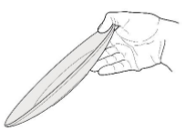
Working with one or both hands above shoulder height  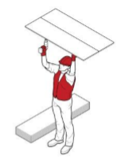 |  | Reaching forward or sideways more than 30cm from the body  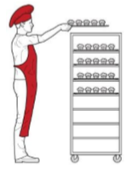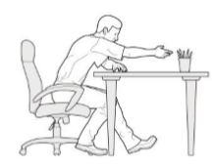 |  |  |  | Reaching behind the body  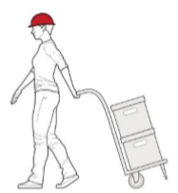
Standing with most of the body’s weight on one leg  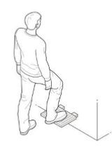 |  | Working with the fingers close together or wide apart  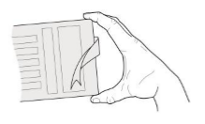 |  | Squatting, kneeling, crawling, lying, semi-lying or jumping  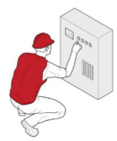 |  |  |  | Very fast movements, for example packing bottles from a fast moving process line  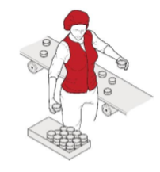
Repetitive force - using force repeatedly over a period of time 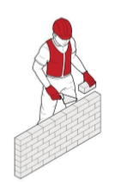 | Examples of repetitive force include:  - lifting and stacking goods onto a pallet  - gripping and handling bricks when bricklaying  - repetitively pressing components with the thumbs or other part of the hand to assemble an item  - cleaning and preparing surgical equipment  - prolonged application of therapeutic massage treatment  - removing splinting material from patients using shears. |  | Sustained force - occurs when force is applied continually over a period of time  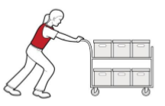 |  |  |  | Examples of sustained force include:  - pushing or pulling a trolley around hospital wards  - holding down a trigger to operate a power tool  - supporting a plaster sheet while fixing it to a ceiling  - carrying objects over long distances  - supporting, positioning or stabilizing a patient’s limb during surgery or when applying splinting or casting material.

High force – occurs when increased muscle effort is required in response to a task  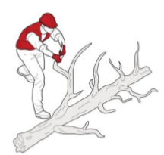 | Examples of high force include:  - lifting, lowering or carrying a heavy object  - lifting, lowering or carrying an object that can not be positioned close to the body  - pushing or pulling an object that is hard to move or stop  - applying uneven, fast or jerky forces during lifting, carrying, pushing or pulling  - applying sudden or unexpected forces  - restraining a person or animal. | Sudden force – jerky or unexpected movements while handling an item or load where the body has to suddenly adjust to the changing force  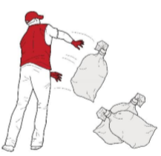 | Examples of sudden force include:  - impact recoil of a large nail gun  - throwing or catching objects  - cutting reinforcement steel with large bolt cutters  - carrying an unbalance or unstable load that suddenly moves  - handling frightened or resistant animals  - handling patients who suddenly resist or no longer assist during the handling procedure.
Repetitive movement – using the same parts of the body to repeat similar movements over a period of time  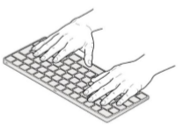 | Examples of repetitive movement include:  - painting  - lifting goods from a conveyor belt and packing them in a carton  - typing and other keyboard tasks  - repeatedly reaching for and assembling components in electronics manufacturing  - using a socket and ratchet or spanner to unscrew long bolts. | Sustained posture – where part of or the whole body is kept in the same position for a prolonged period  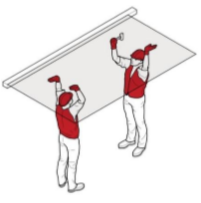 | Examples of sustained posture include:  - supporting plasterboard sheeting while it is nailed into place  - continually standing with weight mainly on one leg while operating a power press with foot pedal controls  - prolonged sitting at a workstation.
Awkward posture – where any part of the body is in an uncomfortable or unnatural position  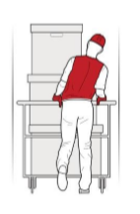 | Examples of awkward posture include:  - squatting while servicing plant  - working with arms overhead  - bending over a desk or table  - using a hand tool that causes the wrist to be bent to the side  - kneeling while laying carpet  - bending the neck or back to the side to see around bulky items pushed on a trolley. | Vibration  Whole body – occurs when vibration is transmitted through the whole body, usually via a supporting service, such as a seat or the floor in heavy vehicles or machinery  Hand-arm – occurs when vibration is transferred through a vibrating tool, steering wheel or controls in heavy machinery to the hand and arm  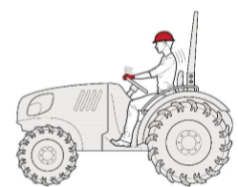  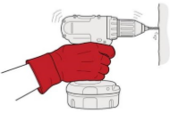 | Examples of whole body vibration include:  - operating plant such as heavy earthmoving machinery  - driving a vehicle over rough terrain.  Examples of hand-arm vibration include:  - using impact wrenches, chainsaws, jackhammers, grinders, drills or vibrating compacting plates  - using needle guns in de-rusting metal.

