Abstract title

C.H. Wang¹, B. Gludovatz^{2,*}, B.C. Thirdauthorfamilyname³
¹University of New South Wales (UNSW Sydney), School of Mechanical and Manufacturing Engineering, Sydney, NSW 2052, Australia
²University of New South Wales (UNSW Sydney), School of Mechanical and Manufacturing Engineering, Sydney, NSW 2052, Australia
³University, School, City, Country

The abstract should be in English and not exceed 1 page; please follow the format and style described in this template – paper size A4 (210 mm x 297 mm) – and do not change page margins. Use font type Times New Roman, with single spaced lines. Title of the paper (14 points, bold) is followed by one blank line. The presenting author’s name should be underlined. Author names (12 points, centered) are written in a single row, separated by commas; authors’ affiliations (10 points, italic, centered) are written in separate rows. Corresponding author and email address of the contact person are listed as footnote. Abstract text (11 points) in paragraphs. The abstract can but does not have to contain equations, figures, and/or references.

$$E=m c^{2}$$ | (1)

Equ. 1 is from Einstein’s 1905 paper on his E = m c² theory [1], and Fig. 1a,b show examples of crack resistance curves of additive manufactured AlSi10Mg [2] and 18Ni-300 maraging steel [3], respectively.

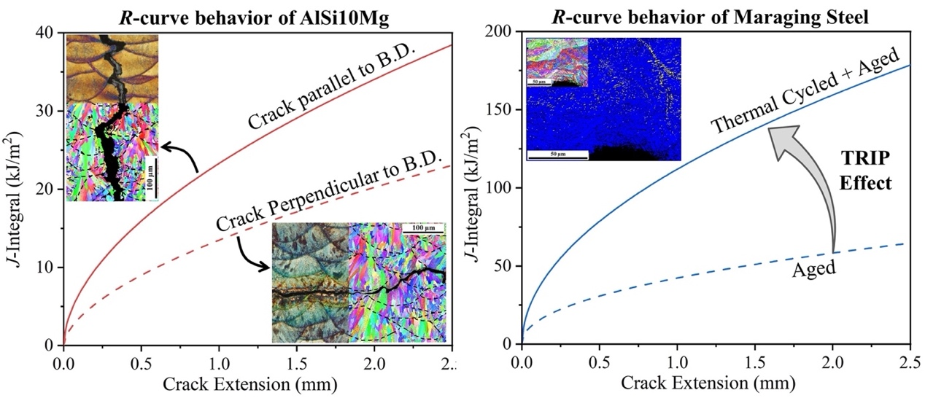Fig. 1: Impact of (a) testing orientation on the crack resistance curve behavior of AlSi10Mg, and (b) heat-treatment on the fracture resistance of 18Ni-300 maraging steel.

References
[1] Einstein A. Ist die Trägheit eines Körpers von seinem Energieinhalt Abhänging? Annalen der Physik 1905; 18:639–641.
[2] Paul MJ, Liu, Q, Best JP, Li X, Kruzic JJ, Ramamurty U, Gludovatz B Fracture resistance of AlSi10Mg fabricated by laser powder bed fusion. Acta Mater. 2021; 211:116869.
[3] Paul MJ, Muniandy Y, Kruzic JJ, Ramamurty U, Gludovatz B. Effect of heat treatment on the strength and fracture resistance of a laser powder bed fusion-processed 18Ni-300 maraging steel. Mater. Sci. Eng. A. 2022; 844: 143167.

